Scottish Islands Peaks Race 2015
Yacht Laura - Race report

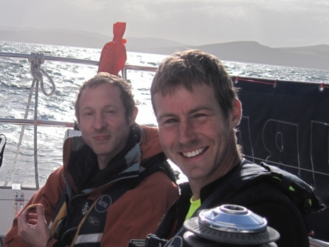
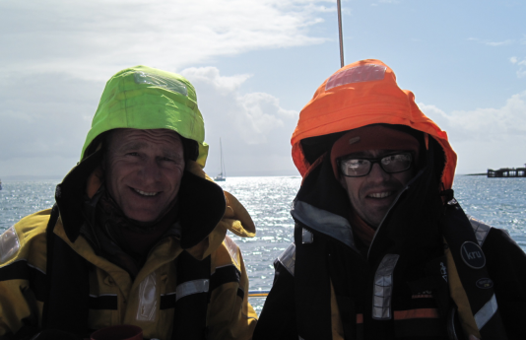
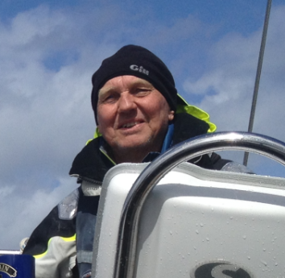

Richard Stain (Skipper) , Carl Davies (crew), Ed Simmons (Crew and reserve runner), Lee Bowden (runner), Graham Hill (runner)

“It’s not that hard” said Graham, sitting over a full Scottish breakfast in Troon marina restaurant on Sunday morning, “all you have to do is land on an island and start moving your legs”.
As an understatement, that is quite astounding. In reality running the hills and mountains during the Scottish Islands Peaks Race is one of the toughest fell runs in the calendar. Graham and Lee had just run 60 miles, climbed 11,500 feet in wind and rain, then tried to get some sleep in a pitching yacht as we sailed the tides and races of the Scottish islands and the notorious Mull of Kintyre.
For the sailors, we all knew the forecast was for strong winds and that is what we wanted, Laura is a heavy boat weighing in at 10 tonnes and she likes a good breeze. But you can have too much of a good thing.

To begin at the beginning. We’d had a decent start from Oban and a gentle sail across to Mull. Halfway to Salen we blew out the spinnaker which cost us a some places but otherwise it was an uneventful sail. We dropped our runners off, our heroes, the anchor set first time and we got our heads down to catch a few precious hours sleep.
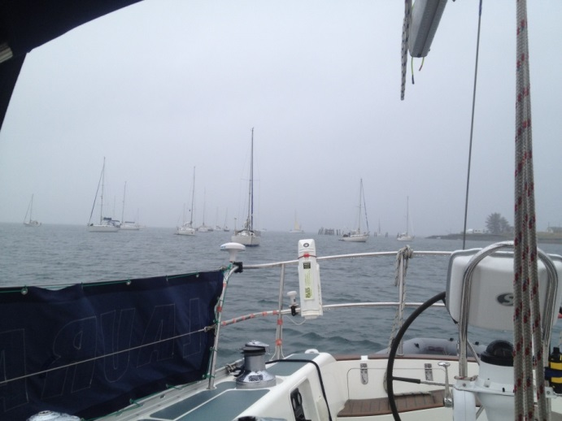

A grey afternoon at anchor at Salen

Graham takes over the narrative.
A quick gear check, a hand shake and we were off. A steady slog along an undulating road for a few miles to the bottom of Ben More. Re-living this is a little traumatic! It got tough. It was bloody freezing and blowing a hoolie. Somehow we managed to find the check points and run/tumble off the mountain back to the sea to find Carl. That’s pretty much all there was to it, other than, I don't think he would mind me saying, Lee was not having fun! But up on the side of a high scree slope staggering around looking for that damn coll I knew he was made of the right stuff, he was having a nightmare but was still bouncing along and smiling, so with a few gels and a bit of a game plan we cracked on. This next section needs a title of it's own.
Shepherds Pie.
I really cannot thank you three sailors enough.
The sailing sections all blur into one. My only thoughts are that the sailors were incredible! I knew Dick and Ed from previous races. Either the tip of their mast way off ahead, or the bow of Laura coming into Troon a whole 5 minutes after Highland Spirit. I know Carl knows his barnacles, but seeing the sailors not only keeping the boat on course whilst getting smashed about by the sea, but singing a bloody song!
Skipper
For several weeks before hand I’d been studying the tides, trying to decide if and when to take the passage outside of Jura. Last year, we’d just, only just, failed to get through the sound of Luing and spent a frustrating 6 hours circling behind Fladda, waiting for the tide to turn, while the slower boats caught us up. That was awful. I’d decided that if we arrived at Insh between the hours of 21.00 and 01.00 we’d go outside Jura, otherwise we’d take the Sound of Luing, even if it meant a wait of an hour or so. As it turned out we arrived at Insh just a few minutes after 1pm so the inner passage it was. Would it have made sense to go outside Jura had we arrived 2 hours earlier? Probably not – it would have been quite rough outside and the strong winds meant it was possible to force a passage through the sound of Luing anyway. And I see from the tracker that all boats stayed inside, at least, all boats carrying a tracker did. .
We had a great sail overnight down the length of Jura, the wind was perfect and we hunted down Wildwood, overtaking her just before arriving at Craighouse. I don’t think we put in a single tack, other than that required to get into the harbour.
There was lots of silliness en route as always, this time it was videoing each other singing – “It’s the Crinan Canal for me. Those great rolling breakers. They give me the shakers. It’s the Crinan Canal for me!”
The mountain whippets were released and once again the sailors settled down to warm sleeping bags, sweet tea and sweet dreams. But it was not to be. There were only troubled dreams as the wind howled and screamed in gusts making my blood run cold. During one particularly strong gust I saw F9 on the wind speed instrument.

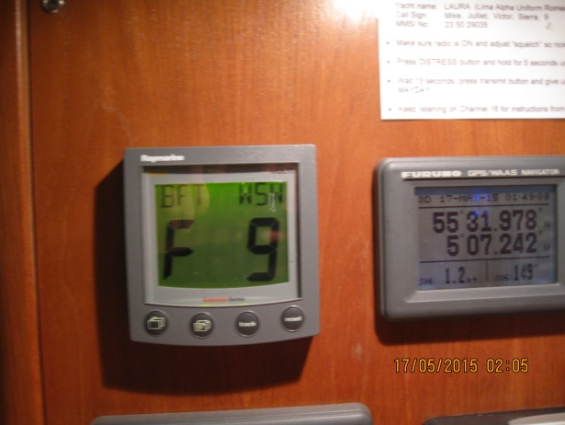

The inshore waters forecast was “WSW F5-7, gale F8 in the west. Sea state moderate to rough becoming very rough to high” Hmmmm, I don’t mind admitting I was worried, more than worried. Here we were, preparing to sail round the Mull of Kintyre, with it’s notorious races and overfalls in winds that could reach gale force and in very rough seas. I’d sailed the Mull many times and knew what to expect, it was going to be nasty. What to do? Retire? No, it was unthinkable, let’s just get the boat well prepared, some food in our stomachs and imagine ourselves 12 hours hence, gently swinging at a mooring in Lamlash Bay.
Laura is a strong boat and we had a good crew, you don’t get much better than Ed, who once sailed for Ireland and Carl who is a professional fisherman out of Conwy and who spends over 200 days a year at sea, he sort of knows what he’s doing. So we put in a third reef in the main and went and picked up our runners, looking surprisingly fresh after running the Paps of Jura. “Well done lads, food’s in the oven, chicken and chorizo” Off we go!.
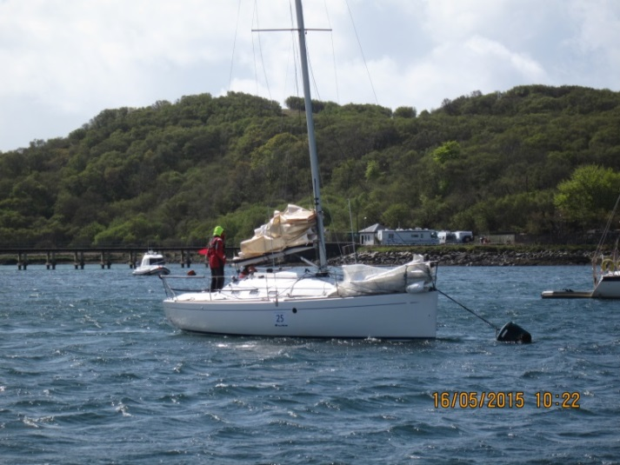

Rebel anxiously awaits her runners at Craighouse

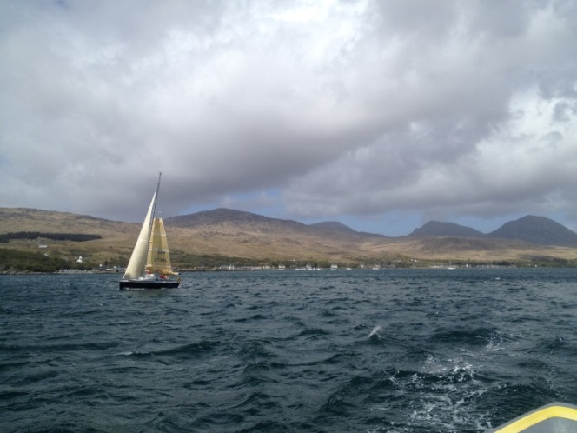

Wildwood leaving Craighouse with the Paps of Jura in the background

Graham on Jura.
Lee needed convincing it was normal to feel awful, he just needed to turn out and start running. As it happened Lee seemed to get stronger as the Jura stage went on. We had sun, rain, hail and a full blizzard. The navigation was straight forward, but it was my turn to feel the heat, Lee was bouncing down the Paps and seemed to be getting faster as the day went on. My shoes were misbehaving, giving me painful toes. We had a short stop after the last Pap, filled our water bottles and headed full steam to chicken and chorizo served at an impossible angle.
Skipper
With three reefs in the main we tracked along nicely, the wind was strong but we were in the lee of first Jura and then Islay so there was no real fetch to the sea. As we headed further south we began to pick up some swell from open water but the sea state was never more than moderate, possibly rough at most.
We’d discussed how to round the Mull, whether to go inshore to miss the race or go outside of it, a detour of some miles. We decided to be prudent and go outside, after all we were on a lee shore with still strong winds. But as we tracked south I felt Laura being pulled to the inshore passage, the seas looked OK and Wildwood was following us. I also knew that the tide turned in our favour an hour earlier inshore so we pressed on.
We picked up a good tide and although we went through the race, it was choppy but quite benign. Nothing like I’d been dreaming about!
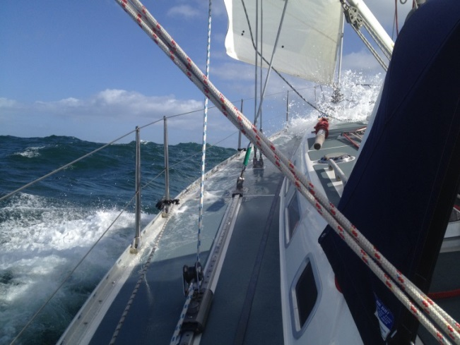

Laura at the Mull of Kintyre

Best of all, we suddenly saw Warrior, Rebel and Sonata due south of us, they had gone outside and we had gained at least two or three miles on them. O joy! If only we could overtake Cris in Rebel, our rival from Conwy Yacht Club – how good would that be!
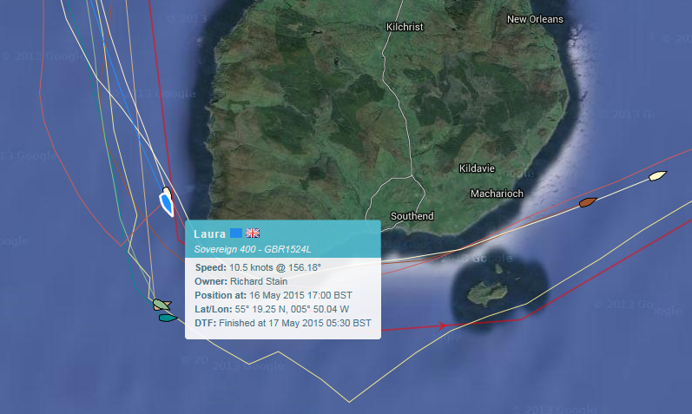

Laura picks up some tide approaching the Mull. 10.5 kts over the ground.

But the wind dropped as we rounded the Mull and with a nice 20kt WSW breeze we were in dire need of our spinnaker. So sadly, we had to watch Warrier and Rebel, spinnakers flying pull away from us again. We’ll get you one day Cris.
At Lamlash Bay we dropped our runners with some difficulty. Our particular technique is to tow the dingy astern while still under sail, with runners and rower in place. Then we sail as close as we dare to the landing point and let slip the dingy at an optimum position. This time the wind was blowing almost directly offshore and Carl, our rower in the dingy shouting “You’ll have to go in closer, I can’t row against that!” Me yelling back “We’ve only got half a metre under our keel, I daren’t go much closer” Weaving in between other boats and mooring buoys, thank goodness it wasn’t dark. “Go, now!” and they were off.
Our brave runners, this one would be in the dark, but at least the sailors were feeling relaxed now the Mull had been rounded, just the sail to Troon to go now.
Relaxed? Did I say relaxed? “Wake up Dick, wake up, we’ve dragged our mooring” 01.00 am and Rebel radioed us to say we were dragging and only metres away from them. Pitch black, raining hard, wind battering us, as we cast off, Carl at the helm. “Mind that boat, look out for that buoy!” Picking up a new mooring, I dropped the boat hook, it slipped through my fingers like an eel. Happily it floated and I was able to climb into our dingy and retrieve it.
Safely on a new mooring, deep asleep, when my phone rang. Wow, that was quick, is it time to get up already? But it’s only 2am and it’s my wife on the phone from home in Cheshire, “Dick, I’ve just had a call from Graham and he ………………………..” The phone went dead, no signal! And still no signal. This was worrying, had the runners had an incident on Goat Fell? What was going on? On the shore Carl, phoned Jenny on a land line. Naturally, she was delighted to be phoned a second time in the middle of the night, but thankfully it turned out that Graham had called my home number by mistake, just to let us know they were nearly back. Phew! All’s well.
Graham on Arran.
We arrived here after what seemed like half an hours sailing. We were turfed out by our friendly oarsman and set to work on Goat Fell. Hard to believe, but the weather was terrible, strong winds and driving sleet. We powered on, Lee was in good stride and I had different shoes. The check points came and went and the summit reached in good time. Then we went for it! Lee and I worked well, taking turns to find good lines in poor visibility, the next runners we saw were miles behind! We just had to stay on our feet as we gunned it down the mountain, a short stop to refuel in Broddick and we slogged it out over to Lamlash. The final push saw us fall into the dingy then get hauled aboard Laura.
I am sure she is a lovely boat, but my memories are very fleeting, because the sailors were so damned quick! As soon as we started to get some rest we arrived in Troon! Into the dingy and a run up to the finish.
What a trip! The tougher the sailing got the more you guys seemed to enjoy it! I had a great time running with Lee, he was never anything but positive and cheerful. We both had peaks and troughs but we shoved each other along to a great result.

Skipper
The last leg sail to Troon can be an anti-climax but not this time. As it turned out, we had a downhill sleigh ride of a trip to with the wind just off the stern, surfing down the biggest waves we’d seen all weekend. 11 knots at times. It was fabulous. And later we found out that we’d made the 2nd fastest time of the fleet for that leg, beaten only by Wildwood.

A great race, many thanks to the organisers, we’ll see you all next year.
An appropriate song to finish.
https://www.youtube.com/watch?v=0a-_Rdtbnow

