**Scottish Islands Peaks Race 19-21 May 2023**

Boat - Elixir of Lorn

Team- Andrew Chapman (skipper), Alex Spence, Mark Taylor, Joe Stringer, Will Bowers

I have to say straight off, that this was one of the best weekends of my life, an incredible experience from start to finish. The SIPR had been on my bucket list since I first heard about it, although I had no idea how I would go about finding a place on a team. When therefore, I got a message from Will about 4 weeks out from the race asking if I wanted to join him and a boat he’d found, I snapped his hand clean off.

The race is for teams of sailors and runners covering over 160 nautical miles at sea, and over 60 miles running over the highest peaks of Mull, Jura, and Arran. Whilst I was confident I could handle myself in the hills, I had hardly any experience of sailing. I have, however, watched all the episodes of Hornblower multiple times and figured I would just attempt to channel some powerful Horatio Hornblower energy and stoic mindset if the going got tough.

**Run 1 - Oban. 6.5km / 215m / 31:56**

[**https://www.strava.com/activities/9099586273**](https://www.strava.com/activities/9099586273)

Will, Mark, and I arrived in Oban on the Thursday night and went straight to race HQ to sign on and complete our kit checks. I was keen to meet people and get a feel for things. In my enthusiasm, I needlessly attempted to charm the race organisation with offerings of Malteser Cake Bars, (incredible, life changing confectionary items). Then followed some fish and chips in the town whilst Mark shared some of his memories of Newcastle, including an amazing story about getting separated from his mate on a night out when said mate went home with a girl. Then the following morning, lost and alone in an unfamiliar city, he found the house his friend was at, by simply asking a stranger on the street something like, ‘Do you know which house the “girl with the really large breasts" lives in?’, as if there was only one of them in the whole city! Incredibly he was given a street and door number and it turned out to be right. Classic salty banter from a classic salty seadog. I was in for some weekend, I thought to myself.

Anyway, about the race. Starting at the Oban sailing club we began with a short race up Pulpit Hill to thin out the field and stagger the boats leaving the mainland. The race wouldn’t be won here, but I could certainly trash my legs enough to ensure the next couple of runs would include some unnecessary extra pain. It was a fast start and I felt decent, but mindful of not going too deep into the red considering what was to come. We still finished reasonably high up the field and back at the sailing club, threw on our life jackets, clambered into the inflatable kayak and started paddling out to the yacht.

**Sail to Mull 15.4 NM / 04:08:12**

One of the bits I enjoyed most about the race was the paddle from shore to yacht, and yacht to shore at the transition between sailing and running. The little inflatable kayak almost always felt a bit unsteady especially when the adrenaline was pumping, and we were racing to get ashore. It was a really enjoyable additional sense of jeopardy that added an extra bit of swashbuckle to the endeavour.

It felt great climbing onto the yacht and being under sail. We had a few hours to eat a bit of food and prepare for a big run-on Mull. We seemed to have a good bit of wind for this leg, and I enjoyed sitting up on deck, taking it all in, and getting to know my teammates. I couldn’t have asked to be on a better boat with a better crew really. Everyone was super laid back, with a good sense of humour. Essential characteristics I would suggest, for getting through a long weekend sharing a small space and contending with a fair bit of fatigue and stress. Will and I had had a short video call with Skipper Andy a couple of weeks prior, but I hadn’t met Alex before. I’d met Mark the night before at Will's parents’ house in Stirling and he drove us all over to Oban. Within a short space of time, he was regaling us with anecdotes about previous races, and hellish drinking stories, most of which featured this character called The Major. For some reason the idea of The Major really stuck in my head, and he often appeared there over the weekend. Since the sailing world was a mystery to me, was The Major some kind of sailing euphemism or metaphor? My two main theories were that The Major was in fact a projection of Mark's own unconscious, or potentially an immortal Ra’s Al Ghul, League of Shadows figure - more of an idea than a person. See what you have started Mark?

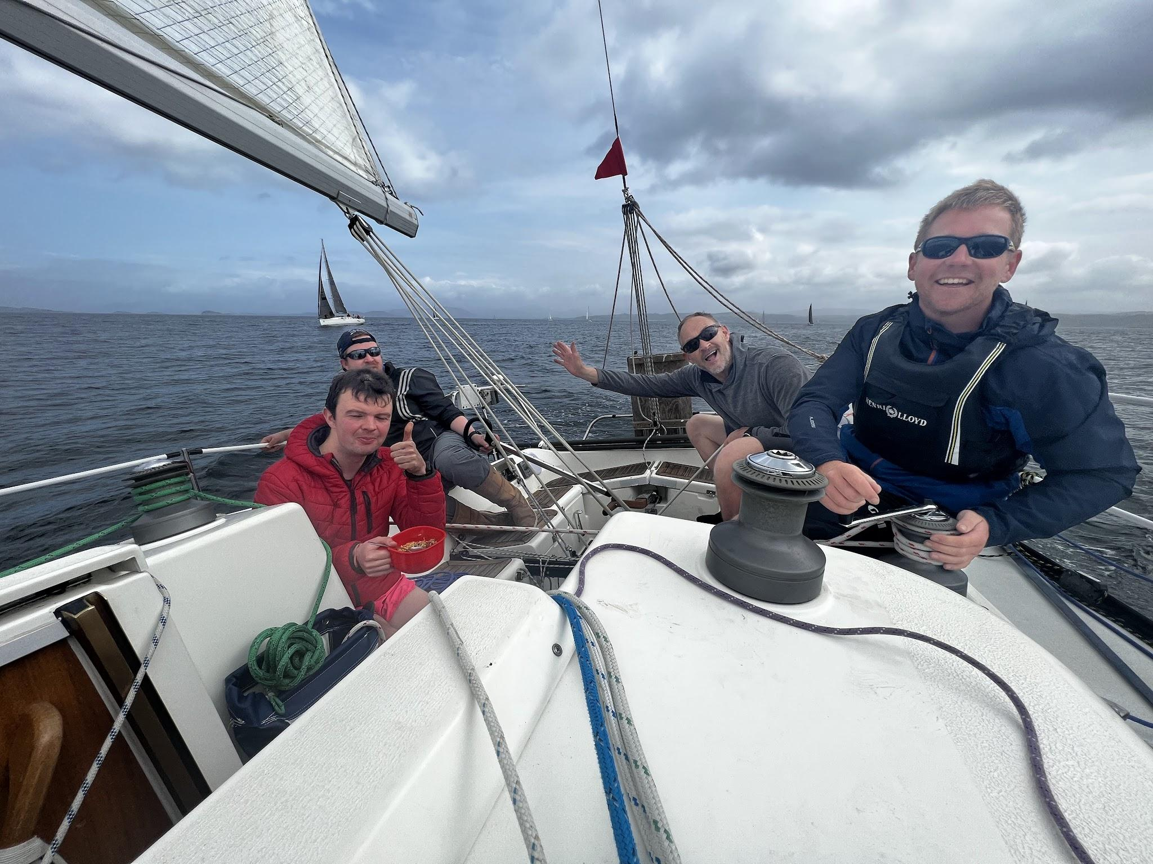

**Run 2 - Mull /Ben More / 37.8KM / 1,196m / 04:50:20**

[**https://www.strava.com/activities/9102225563**](https://www.strava.com/activities/9102225563)

The proper running started now, and one of the bits I was least looking forward to – near enough 10km along tarmac and gravel track before the climb to the mountain starts. At least the leggies were fresh, and we could just tap it out and get it done.

Towards the end of this section Finlay Wild and Joe Symonds of the boat Opportune, came blasting past us. What sport other than fell racing can a weekend warrior type like me race against the very best in the business? It’s like a lower division National League football team getting to play against a Champions League side. Obviously, you’re going to receive something of a drubbing, but you can (briefly) enjoy watching it being dished out and admire some supreme athletes at work.

As it ended up, we beat team Opportune overall as their boat didn’t fare well in the light winds. And yes of course, beating Fin Wild in a race is something I’m going to dine out on for a long time. No need to mention that it was a result of things entirely outside of anyone’s control, like weather conditions and tides.

Meanwhile, in Mull, eventually the hard ground on the approach turned into slow moving, boggy, tussocky ground, before starting the long climb up to Ben More. Toward the top we caught two lake district runners from Jezebel and finished the climb together – I think he said this was his 5th time racing the SIPR and they certainly knew some good lines between the descent of Ben More and the next two controls, which would have been tricky to navigate to if they hadn’t essentially given us an armchair ride to them. (Thanks guys!)

Then followed a seemingly interminable section where we contoured the hillside, gradually descending the side of the valley, but always running on an angle, which my ankles hate. We stopped for a second to get water from a stream and Jezebel were gone. We caught them again on the road, only for them to overtake us once more when I had to pay a very necessary visit to a bush. A fun bit of cat and mousing always makes things interesting.

Will was really having to drag me along on this final road section which I was finding torturous. Will was still in good road form after having ran a 02:45-something at the London Marathon a few weeks earlier, but my legs felt thoroughly paggered. The thoughts of, ‘How am I going to be able to do this all over again in a matter of hours’ were starting to crowd out all other thoughts.

**Sail to Jura 75.6NM / 15:31:58**

Eventually Will and I made it back to Salen, jumped in the kayak, rowed out to, and successfully boarded the Elixir. I necked a cup of tea, fired into the food the lads had made, gave myself a good going over with some baby wipes, and settled into what could be a long overnight sail.

I think I might have managed about an hour’s sleep that night, probably a combination of not being used to the boat, and still being fired up from the race. Thankfully the sea was calm so at least I could lie still and rest and not be thrown from starboard to port every time the boat tacked over.

After, I was chatting with Alex to get the low down on this leg from a sailing perspective. He’d described how hard they had to try to make the Lismore tidal gate, and how that benefitted the rest of the leg, if we hadn’t had made the gate, we could have potentially been looking at an extra 6 hours or so sailing time. He also noted some brilliant sailing we had in the sound of Luing, with flat water and a nice wind. This was in the early hours just as we were passing Scarba and I had emerged from my berth to sit out on deck. The winds died off shortly after and according to Alex - not for the first time, they spent far too long battling the final 5 miles into Craighouse on Jura, with lots of rowing required to get us close enough to the shore to kayak in.

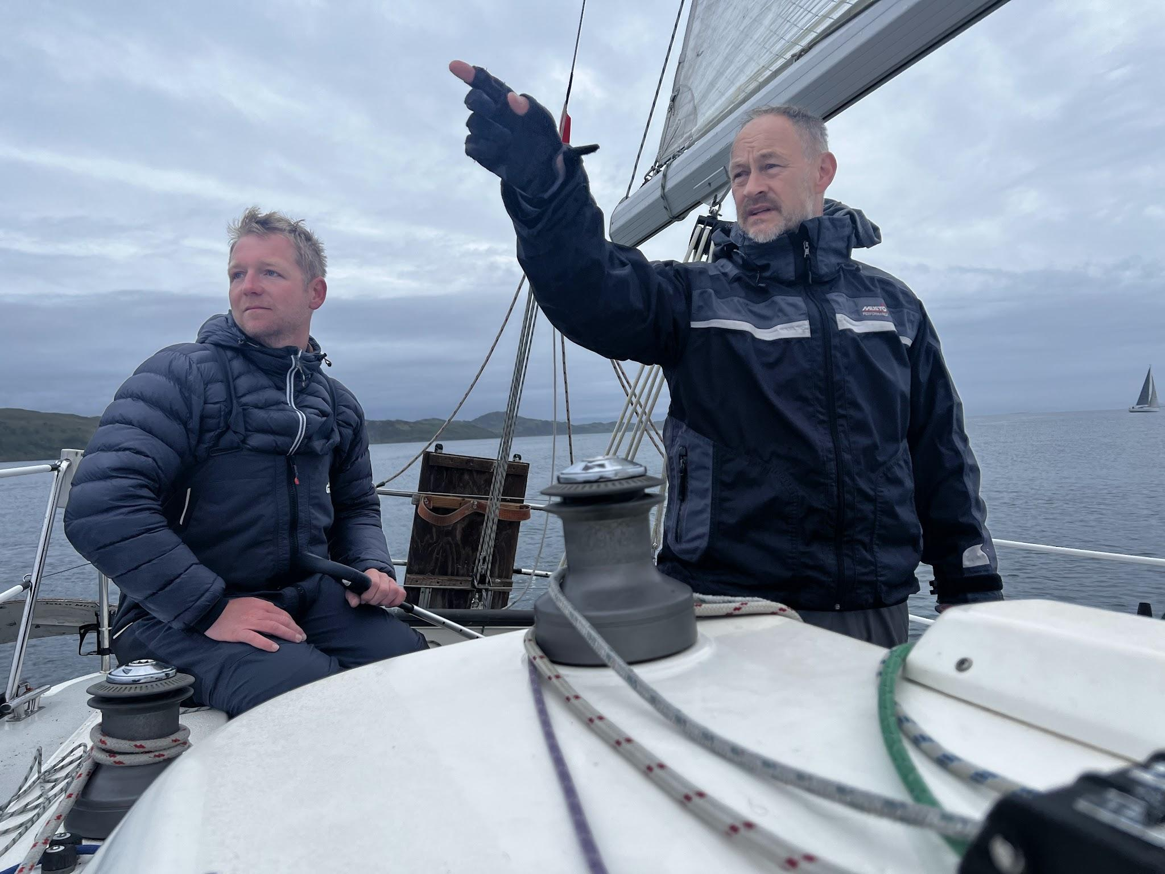

**Run 3 - Jura / The Paps 24.4KM / 1,540m / 04:55:32**

[**https://www.strava.com/activities/9107631858**](https://www.strava.com/activities/9107631858)

I couldn’t quite tell how my legs were on the yacht, but I was pleased to find that once we started running, they were in reasonable condition. The mandatory kit check on Jura was a lot smoother and more efficient than the Mull kit check, where I’d been all flustered, and found unnecessarily stressful. Once we were off and running, we caught and passed a couple of other pairs of runners on the approach to the Paps, which were covered in rain threatening clag. So far so good though, and we climbed well up Beinn a Chaolais, and were briefly treated to a nice inversion, with the summit of Beinn an Oir briefly appearing and disappearing again, like a misty dream into the cloud.

Amazingly we only really had one navigational error during all the running, which was when we couldn’t find the control hidden by the lochan between Beinn a Chaolais and Beinn an Oir. Essentially because neither of us had a note of the coordinates or could remember the description of its location (crucial learning for next time). We faffed for about 10mins looking and I had to start the climb up Beinn an Oir, from which vantage point I was able to see the control and then shout and point Will towards it. I was also able to see Robin Downie and Ross Creber, total hitters from Team Superstition, flying down the descent of Beinn a Chaolais. They caught us a couple of hundred more metres into the climb and were out of sight impressively quickly.

The Beinn an Oir climb was probably one of the toughest and most scrambly, but its descent and the subsequent climb of Beinn Shiantidh were pretty straight forward. Will and I had not run the Paps before and whilst, in general, the on-sight navigation was straight forward, knowledge and experience of the best lines to take on the descents would have saved a lot of time. We hit a good bit of runnable scree coming off the hill which then turned into bigger rocks, which were unstable and on top of that, it had started raining, which made the rock slippery and even less trustworthy. I was glad (and so were Will’s PB’s which had been shredded) when the ground turned soft, grassy, and runnable, and then less glad about the boggy schlep along the Paps walk after skirting Loch an t-Siob. We got passed here by Jasmin Paris and Conrad Rawlik who made the boggy ground over which they were running look like it was nice flat smooth tarmac. Again, I appreciated seeing a fell running legend in full flight.

The rain was getting heavier as we hit the road. Orwell had written his magnum opus on Jura, and whilst our run, in relative terms was no masterpiece, we certainly gave a good account of ourselves and held our position overall. That run had been tough. I was really looking forward to being back on the yacht with the lads. I sort of missed them in a way. I had no idea what he was talking about, but I knew that when I was struggling down the wet slippery rock of Bein Shiantidh I couldn’t think of anything better than being back on the Elixir listening to Mark spin some yarns about The Major. Andy had great calming and reassuring energy, and I wondered if it was too soon in our affiliation to start going in for big hugs.

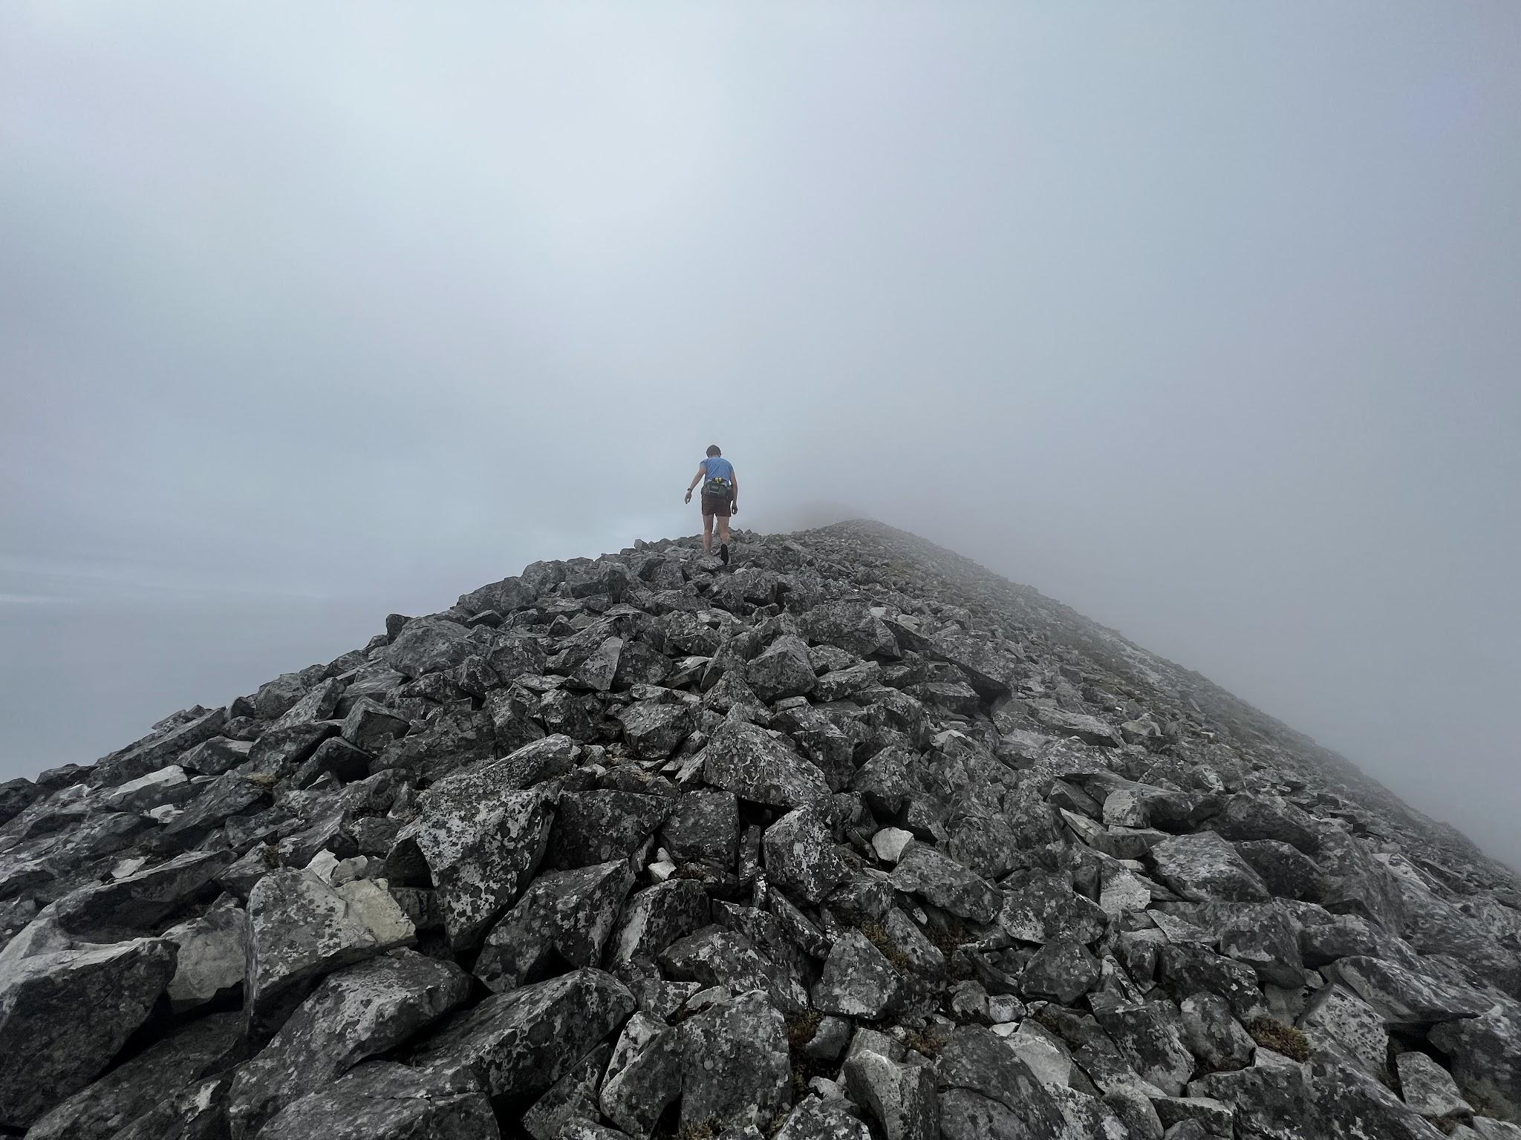

**Sail to Arran 63.4NM 22:01:39**

There wasn’t much time for big hugs or stories back on the boat anyway, as the crew were straight into action, trying to grab hold of any bit of wind available to get us away from Jura and off on the long sail round the Mull of Kintyre. I completed my usual routine of cuppa, scran, baby wipes, and catching up with socials (influencer), and wriggled into my berth where I lay staring up at the darkening sky through the porthole in the deck head, hoping sleep would come swiftly. Thankfully, through sheer exhaustion it did, and I managed a few hours, interspersed with the awareness of the heavy rain that was thundering down on the Elixir.

I emerged in the early hours and went out on deck. The guys incredibly all seemed in great spirits, as it must have been pretty grim through the night with the rain and lack of wind resulting in demoralising slow progress. Alex and the lads had done some massive shifts on the back of the boat rowing, but looked fresh and cheerful, which was good, as there was going to be a lot more of that still to come. The bloke really knows what he’s doing, though, and had some impressive stories to tell about sailing across the Pacific in a yacht not even twice the size of the Elixir.

Alex had said we had rounded the Mull of Kintyre without seeing it once! He said the dense fog, lack of wind, and being swept around by the tide made them super disorientated. Whatever heading we chose, our course over ground was taking us to Islay.

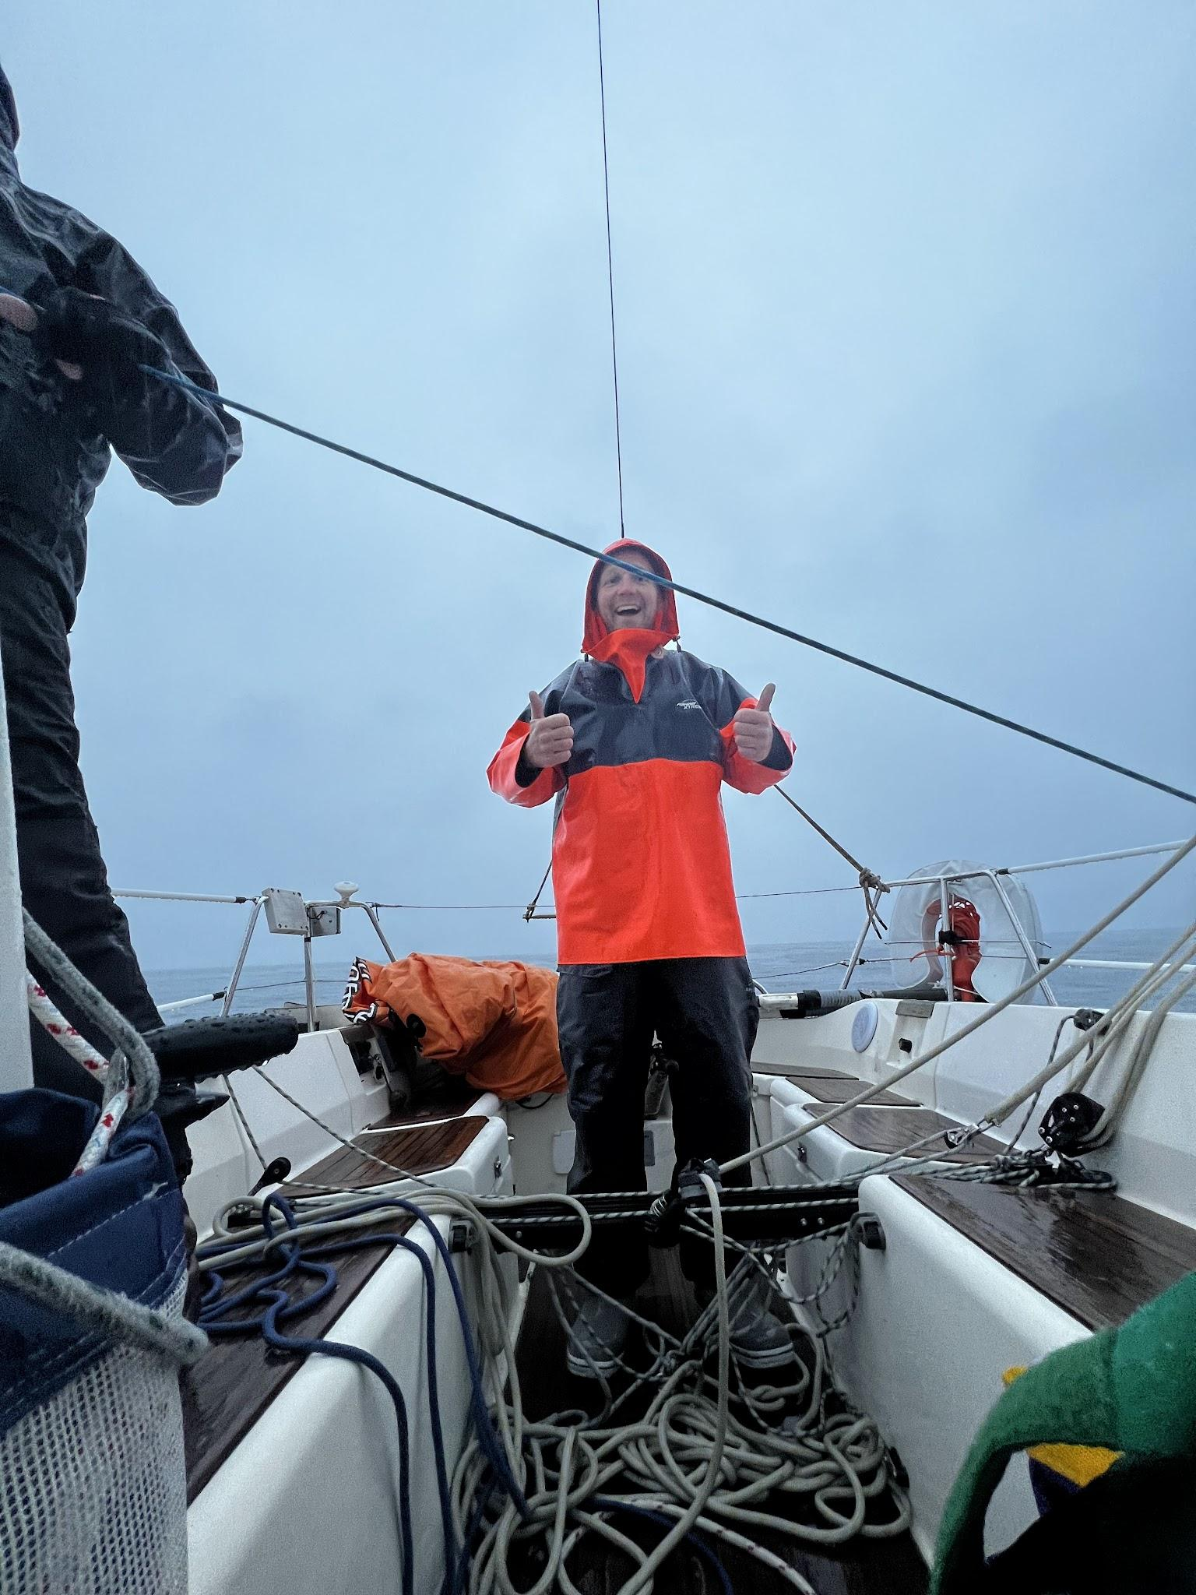

**Run 4 - Arran / GoatFell 31.03KM / 1,263m / 03:47:44**

[**https://www.strava.com/activities/9115279354**](https://www.strava.com/activities/9115279354)

Right then, here we go, the final big run. On paper the most straightforward of them, but still a fair distance, especially with the accumulative fatigue in the legs. As it was, the sensations in the leggies weren’t too bad, and I was just about able to hang on to Will, who was going really well, pushing hard all the way on the climb up Goatfell. The weather was wet going up but the temperature was fine; again, relatively good conditions. Reaching the summit was a great feeling. That’s all the climbing done (apart from the cruel and pointless climb and descent of Prospect Hill in the closing kilometres to Lamlash). We started the descent and I really felt like I was on a suuuuuper day, and tried to push on a bit. Goatfell is easily the best and most runnable descent in the race and I was glad my legs were in good enough nick to enjoy it. A quarter of the way down we passed Jasmin and Konrad coming up the climb, then a few hundred metres after, Ross and Robin from Superstition. Four hitters, hot on our heels. I was determined to really empty the tank on the run back to Lamlash and do everything to try and hold them off. Knowing both pairs were in faster boats meant we would ideally need to start the sail to Troon with a bit of a buffer. It was going to be tough as all four of them are stronger runners than Will or me, but hopefully we had enough of a gap and would not give away too much time.

After running back through Broddick we caught sight of Chris and Angus, the runners from Excalibur III. A fantastic couple of carrots, or hares if you will, to chase. I was still feeling strong, ‘Come on Will, let’s get them, last little bit now, empty the tank, let's bury ourselves!’ What I got back from him were a series of groans and grunts, which grew in amplitude, and frequency, the closer we got to the finish line. Will was wrecked! Fair enough really, he did absolutely hammer it up Goatfell, and we had done a lot of running over the last 55 hours. We did manage to catch the Excalibur III guys just before Prospect Hill, only for them to pull away from us, and dangle about 100m away until the finish, shortly after the descent was done. Nothing left but to grind it out to the finish, and grind it out we did. Will put on a demonstration of utter grit - he was clearly in pain and still making his weird sex noises, but the lad is clearly in possession of the *true dog mentality*, and there was no doubt he wasn’t going to thug it out all the way to the end.

At the end of the run, I knew I could have just kept going and still had more left in the tank. It was great to finish feeling so strong, and such a confidence boost for the rest of this year’s fell running goals. At the same time, I was really looking forward to getting on the Elixir, and being taxied over to Troon with a nice cuppa and some food. If only. In reality, because there was zero wind, and we were dead in the water, Skipper Andy immediately ordered all hands on deck and everyone had to grab an oar and get rowing.

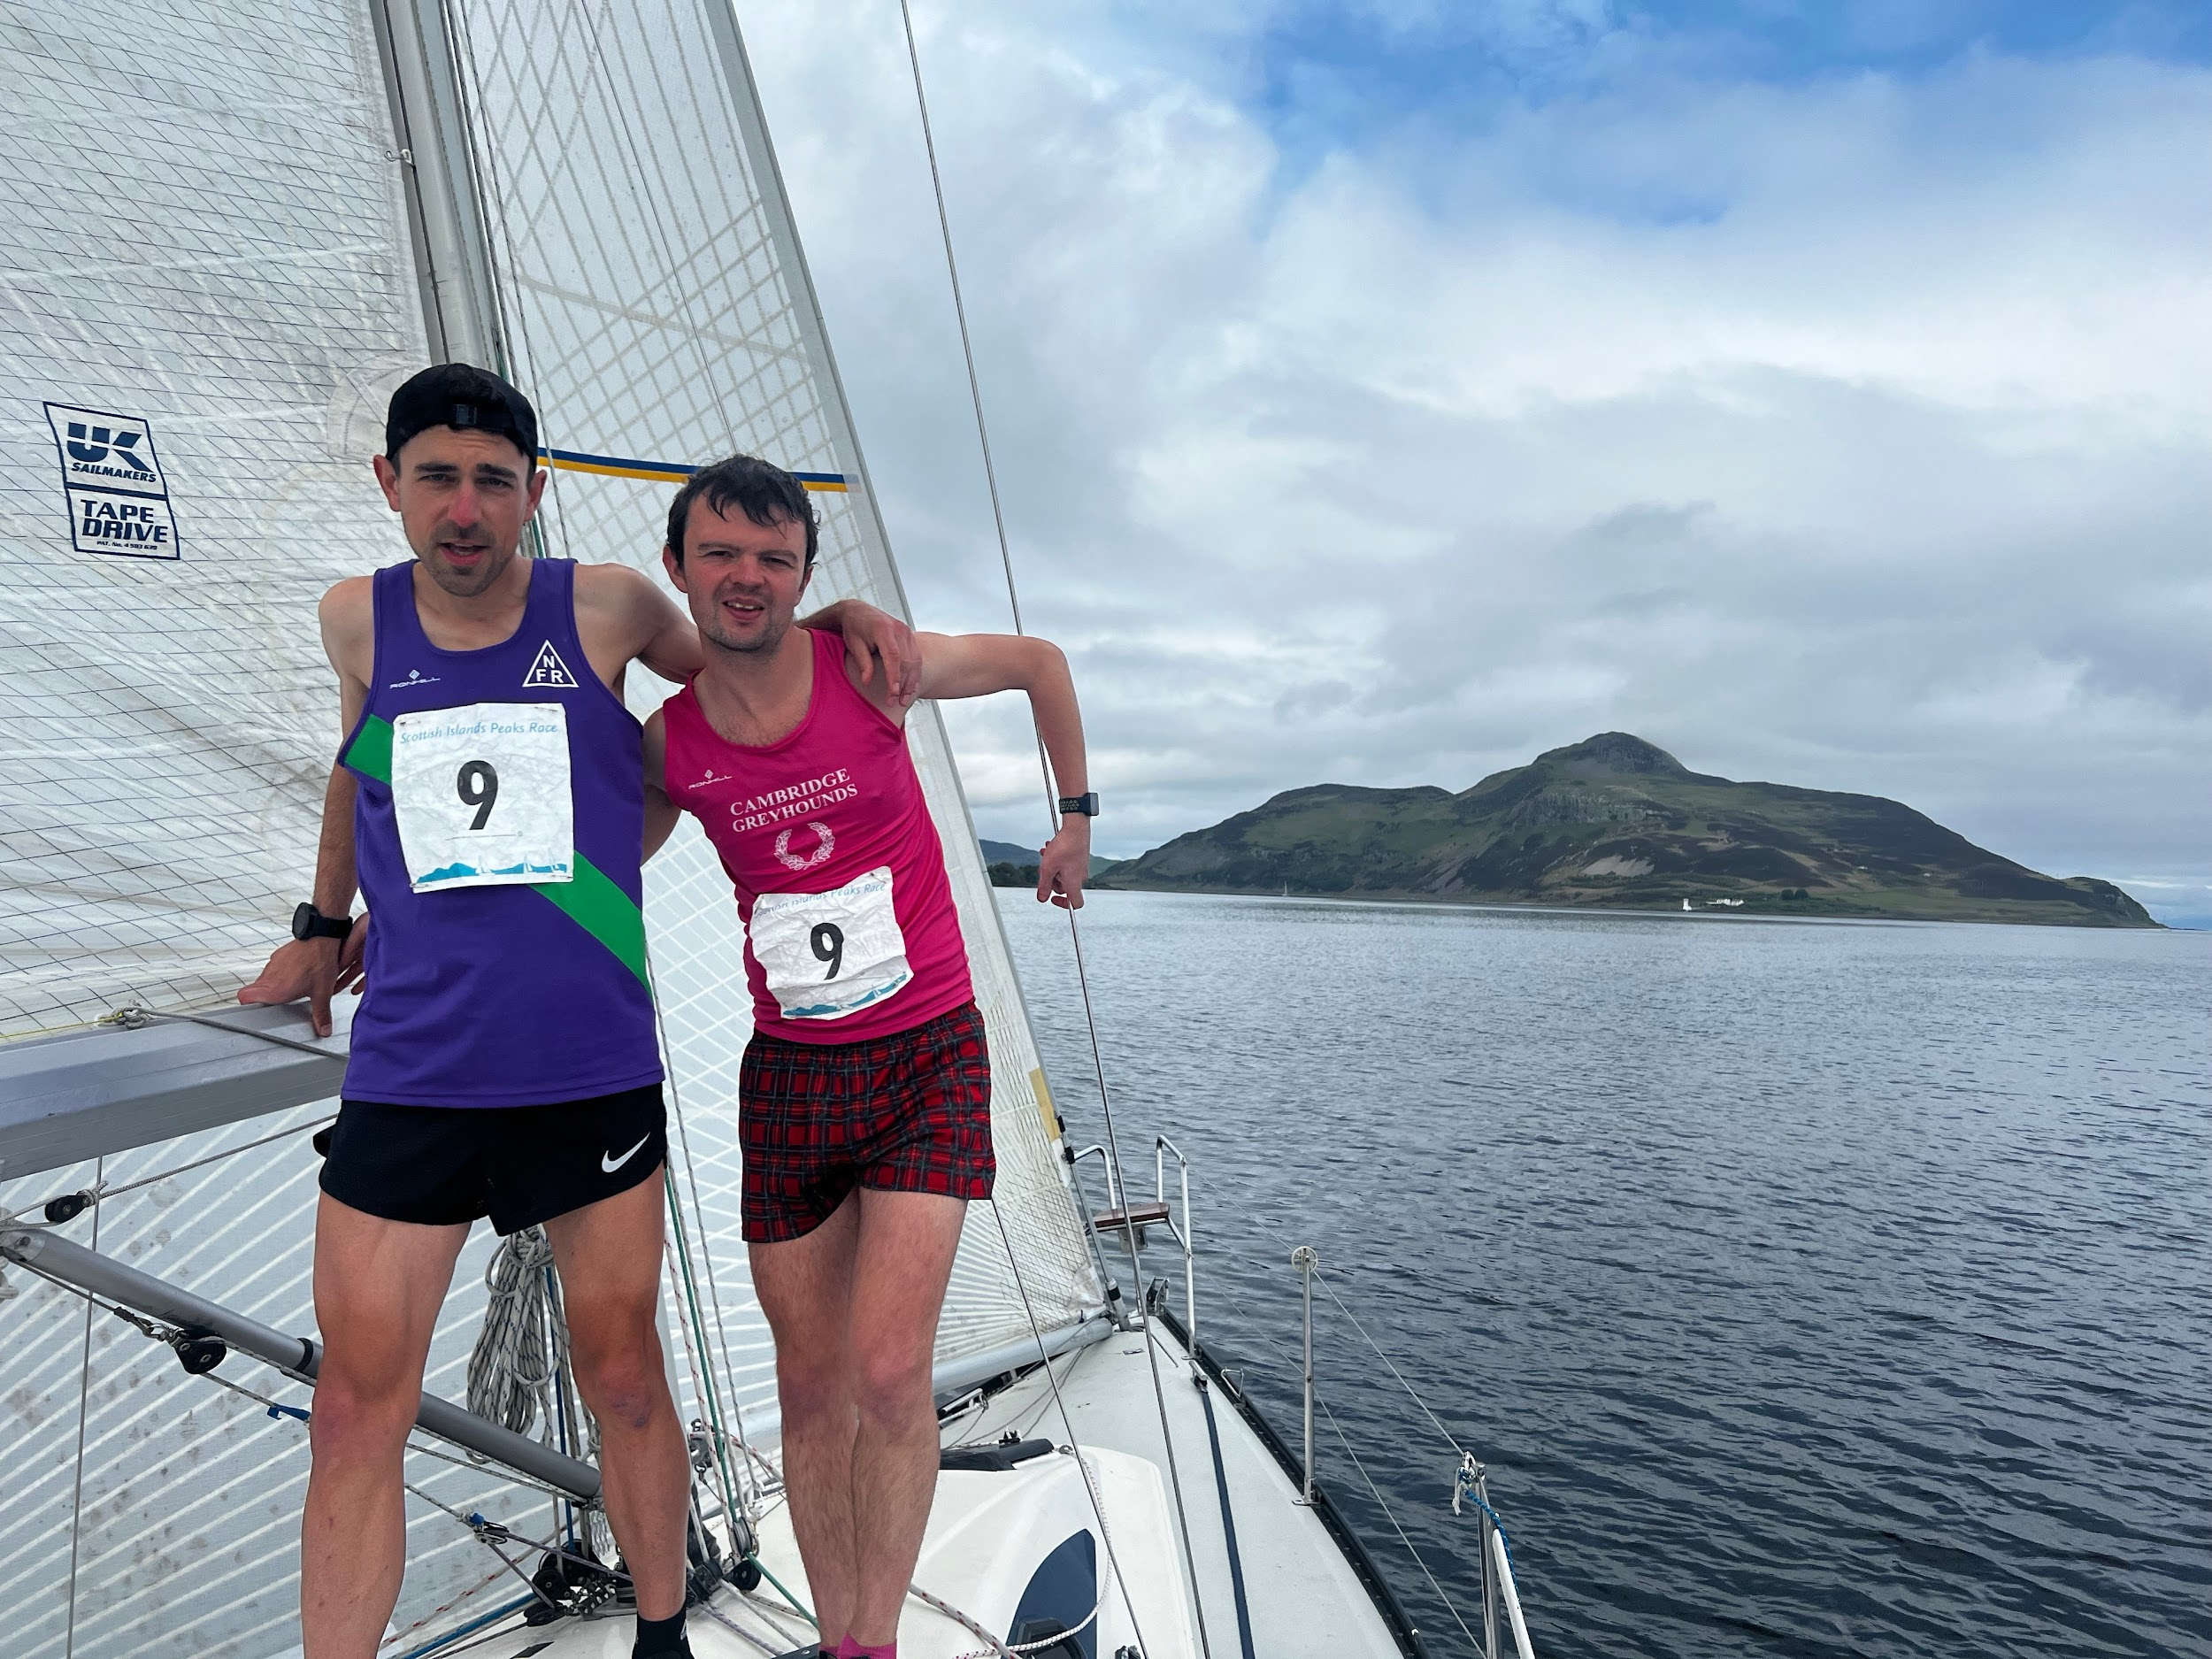

**Sail to Troon 20.3 NM 03:29:28**

The boats of Bequia and Excalibur were in sight, and Andy, Mark, and Alex had made it clear that catching them was the objective. With three of us rowing we duly caught the trimaran Excalibur, but getting Bequia, with its Waverly pedalo machine attachment, was a sterner proposition. I only ended up having to do a couple of shifts rowing before we picked up a good bit of wind. The faster boats of Bequia and Excalibur immediately gained a massive advantage ahead of us, but there was a good gap between any boats behind us, so we were holding our position in the standings.

To be fair, I wasn’t even thinking about the race at this point but rather appreciating the breathtakingly gorgeous sunset over Arran we were treated to as we sailed away from the Island. I drank it all in and nostalgically reminisced about my coming-of-age school geography trip there, snogging Hannah Holman, holding hands at the back of the bus, and romantically sharing the earphones of the Walkman and listening to the new Blur cassette tape. Now I’m writing this, though, I remembered that she then cheated on me with Richard Nicholson and dumped me shortly after. A nice early lesson for little Joe about most good things in life going wrong eventually, and people shitting on you. It’s a wonder I turned into such a sunny optimist really, even enjoying my whimsical musings on the sail to Troon despite the outcome. (Don’t think it worked out for Hannah and Nicholson either unfortunately).

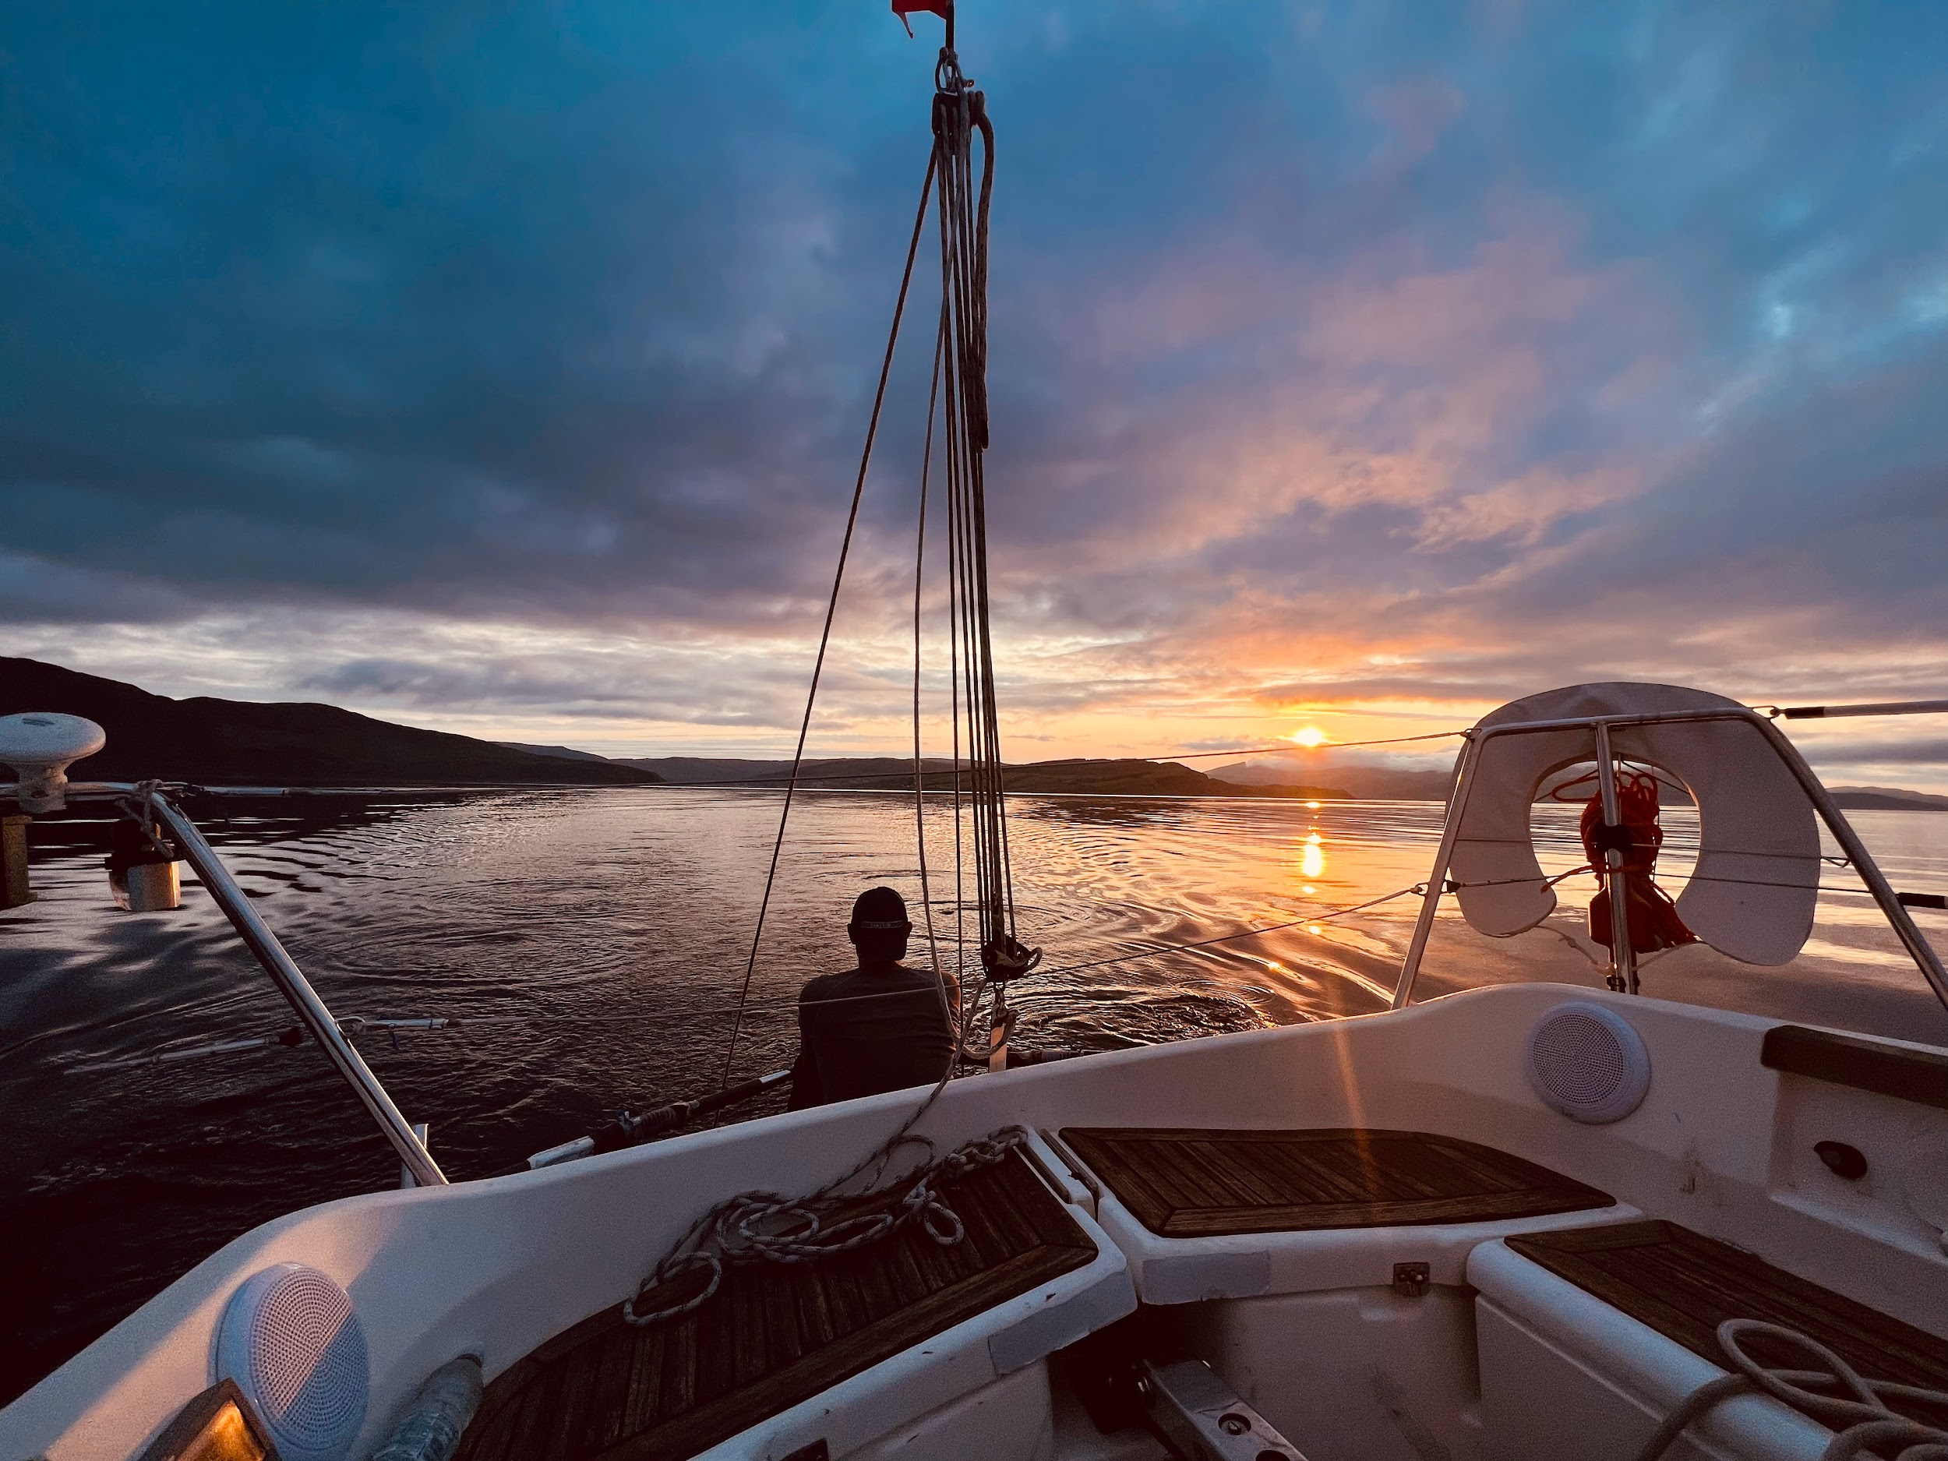

**Run 5 – Troon Yacht Club / 300m / 4m / 02:19 (yes of course it’s on Strava)**

[**https://www.strava.com/activities/9116121839**](https://www.strava.com/activities/9116121839)

The *most* swashbuckling kayak so far with the wind, and ever so slightly choppy sea, spinning us 360 degrees a couple of times before we could collect ourselves and synchronise paddle strokes. Also, more of a limp along the pontoons than a run due to my Achilles, which was screaming at me. We made it to the race office and stopped the clock. 58 hours, 44 minutes, and 53 seconds. First place against the Class 3 monohull teams, and 6th place against all classes. We’d run over 100km, climbed over 4000m, and sailed 174 nautical miles. We took our bottle of champagne and went back down to the pontoons to find the Elixir which had landed at the club, and Skipper Andy duly did the honours, F1 style. After a few words of congratulations with each other, I headed back up to the yacht club for the shower I had been dreaming of ever since Mull, and the deeply upsetting experience of smelling myself after 2 and a half days without even as much as a tramp’s bath in the Elixir’s modest sink – the baby wipes were better than nowt but weren’t quite cutting it after a certain point. Oh, that shower. Undoubtedly, up there with the best and most necessary showers of my life. Then back to the Elixir, and to a deep, well-earned sleep.

**Troon to Newcastle upon Tyne and beyond or the unexpected healing force of the SIPR**

I’m writing this more for myself, than in a, “Hey bro we all have mental health,” type way. The thing is that in the weeks leading up to the SIPR, I would describe myself as being in a bit of a state of pathological mental deterioration. I’d been down in the dumps ever since an out of the blue, and unwanted relationship breakup, and then pretty much being ghosted. Breakups are obviously a common occurrence that everyone goes through, but I’d not really had anything like this one before. Maybe it’s a bit like Covid, which seemed hardly to affect some people, but for others it was curtains. Maybe it’s because instead of learning how to handle breakups as a teenager and in my twenties, at the first whiff of any emotional discomfort, I would just check out and get obliterated with alcohol and drugs (or distract myself with something else that would usually just cause me further harm). That was not an option I wanted for myself anymore, so the age of 38 found me trying to deal with some largely new emotional stuff. Now, out of necessity, I have turned myself into quite a resilient person, but either way, I’d never experienced another person dipping out on me, in the 180-degree manner this lass did, and it fully clattered me. The result was psychological turmoil, subsequently the confusion and distress of which then led to me developing this strange, free-floating anxiety, which believe it or not, I’d never had in my life. I tried to do all the right things to cope and look after myself. My main solace came from increasing training, doing as much running and cycling as I could, and just boshing up and down hills until I was physically and mentally buckled. This would give me some respite from the washing machine head I was experiencing on a constant basis.

Ultimately, what happened was that I got injured, and after a big day running legs 2 & 3 of the Charlie Ramsay Round, the little niggle in my heel that I had been trying to ignore became increasingly painful, until I had to stop all activities. Disaster had struck, and I was worried I was going to be fighting for my life if I couldn’t keep moving. I optimistically went to race the 3 Peaks the following week but DNS’d after too much pain in the warm-up. I did manage to have a nice chat with the legendary Martin Stone in the timing tent he was working in and pick his brains about all things fell running. After a decent week of physio, rehab, and easy stuff, I made it to the start line of the Inter-Counties Mountain Running Championships race in Sedbergh. I had been super proud to make it into the North East Counties Team, wearing the special yellow vest, and I felt in good form and quite confident my heel would hold up. Unfortunately, it didn’t, and I had to limp round feeling sorry for myself. Sometimes, even for me, optimism has limits. No Mountain Running World Championship race Team GB selection for me then, next year, eh?

When I got the call from Will about the SIPR, it was exactly what I needed, at just the right time. - Something positive to focus on, an adventure, a new experience, and an opportunity to contend with some true contentions, like serious terrain, harsh weather, and the limits of my own physicality, rather than the emotional stuff that I was, by this stage, thoroughly sick and tired of, but somehow not quite able to shake off. I kept my worst fears about my injuries to myself, had as many physio appointments as I could, and did everything I could to make sure I was going in as confident as possible that I would make it round. (There’s that optimism again.) In the end, I not only managed to get round in reasonable shape without too much pain, but got round in good time, and more importantly the whole experience seemed to help blow the backdoors off my little mental rough patch.

I was thinking about all this as I travelled back to Newcastle the day after the race finished, in a reflective mood. Whilst I was mega proud of our result, my own, and the whole teams’ performance, I think there was a greater prize. Part of that prize is certainly turning a corner in the raw emotion I had been feeling. But just as big a part of the prize was connecting and sharing in a real adventure with some fantastic people. I can’t think of any sport that facilitates this connection more than fell running. I think about the big rounds I’ve attempted, or supported someone else on, the races, recces, and the training. And the most positive thing about it all, the great healing force, must be the sense of connection – with other people, to the hills (and, in this case to the source of all life - the sea), and ultimately to myself.

So, I’ll finish this report with some thank yous. Firstly, to the SIPR organisation, which was top class, all the marshals, and volunteers who made it work so well. To Will for roping me into it in the first place and dragging me round at certain points of the race, and to Andy, Alex, and Mark, for being such amazing teammates who made the whole weekend so much more fun. I felt proud to be on a team with such a great bunch of guys on it – top blokes and skilful sailors, and to contribute further to this sense of pride – I’m pleased to report that everyone brushed their teeth twice a day. I also better thank my friends and family who had to put up with me moping about, sounding like a broken record in the months leading up to the race. Good news… I’m back!

This wouldn’t be a Stinger race report if it didn’t include some stuff about what food I was eating, so I’ll leave you with a quote featured on my favourite fell running breakfast item.

*“Be the king of all legends, never chicken out, command your wildest dreams to mushroom into reality”* Pot Noodles 2023

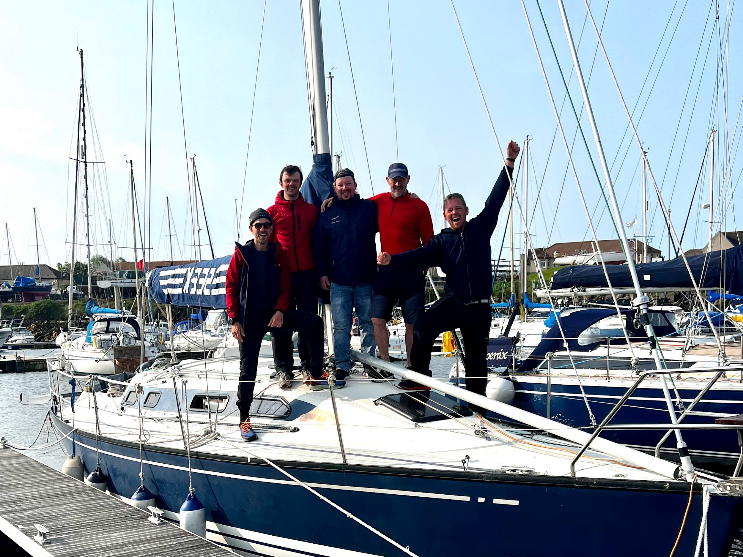

Here’s the link to my video log of the race - inspired by Martin Stone’s incredible account of his 1987 mid winter Bob Graham Round, and serving as a vehicle for some of the new age ambient music I have been producing.

<https://youtu.be/-J5rUVQGnLQ>